Data Analysis and Algorithm

Practical 1

Write a Program to implement Insertion sort

&

Find the run time of the algorithm

Name – Yash Vasudeo Prajapati

Rollno - 022

MSc. Computer Science

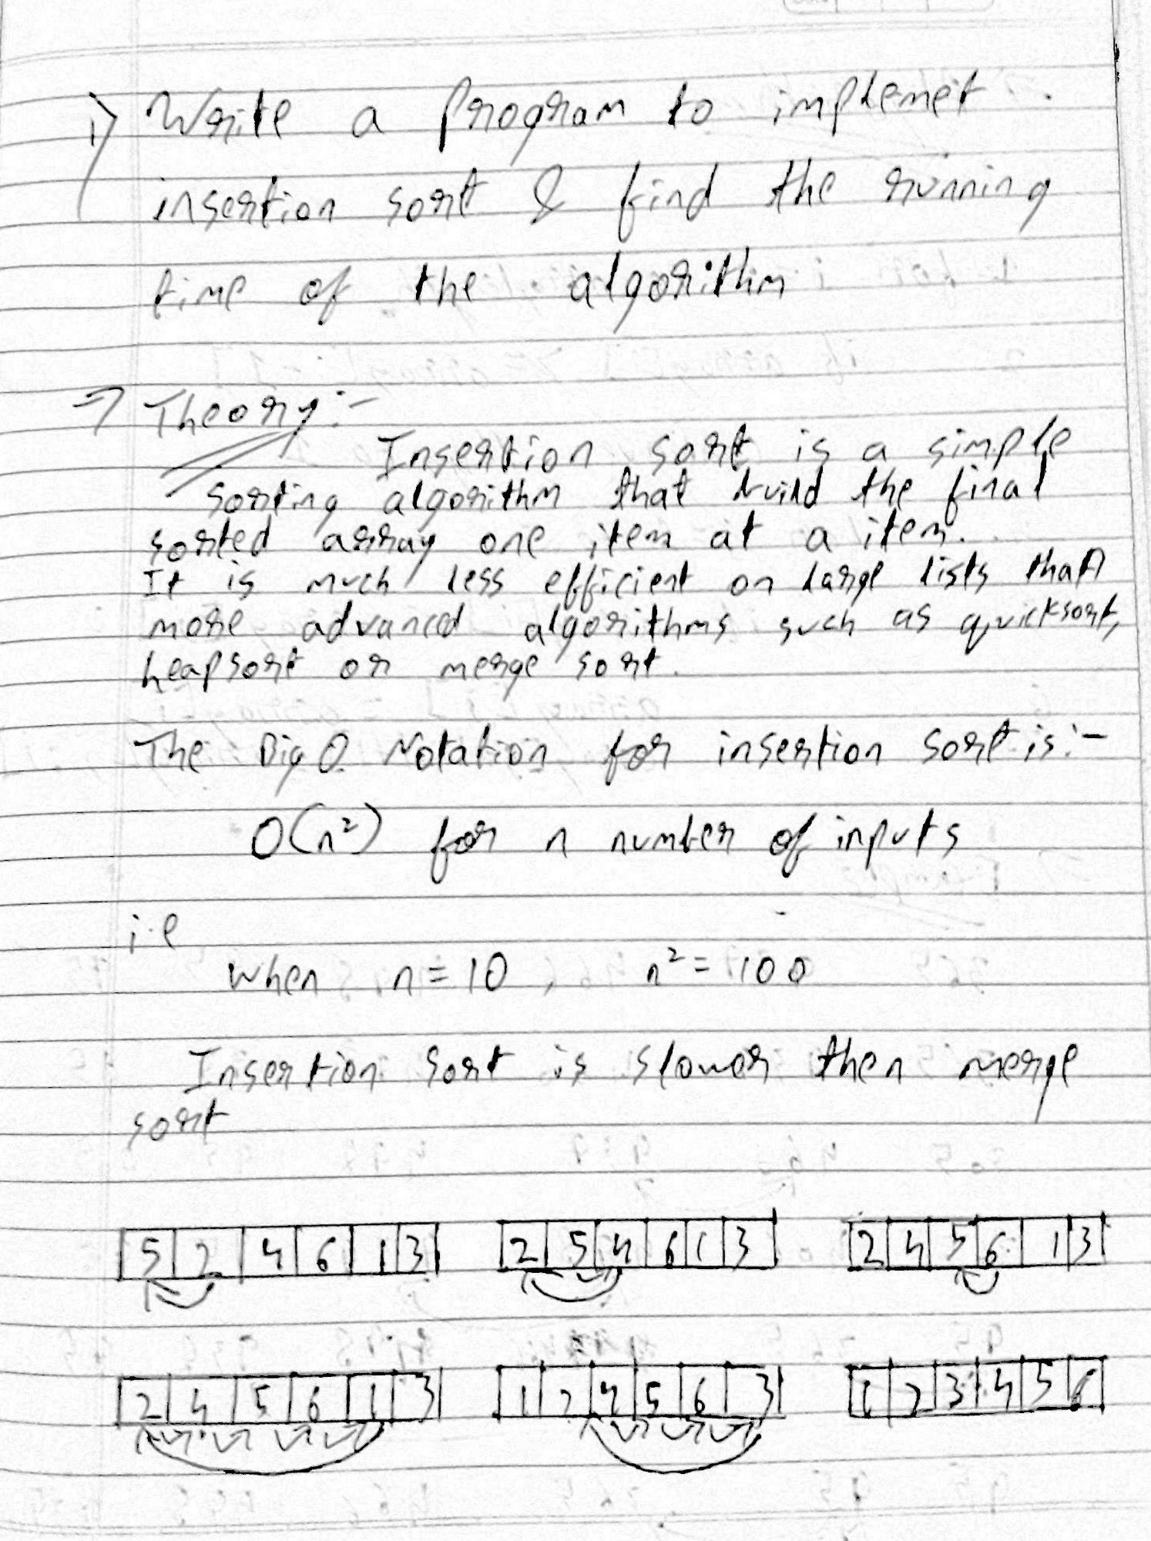

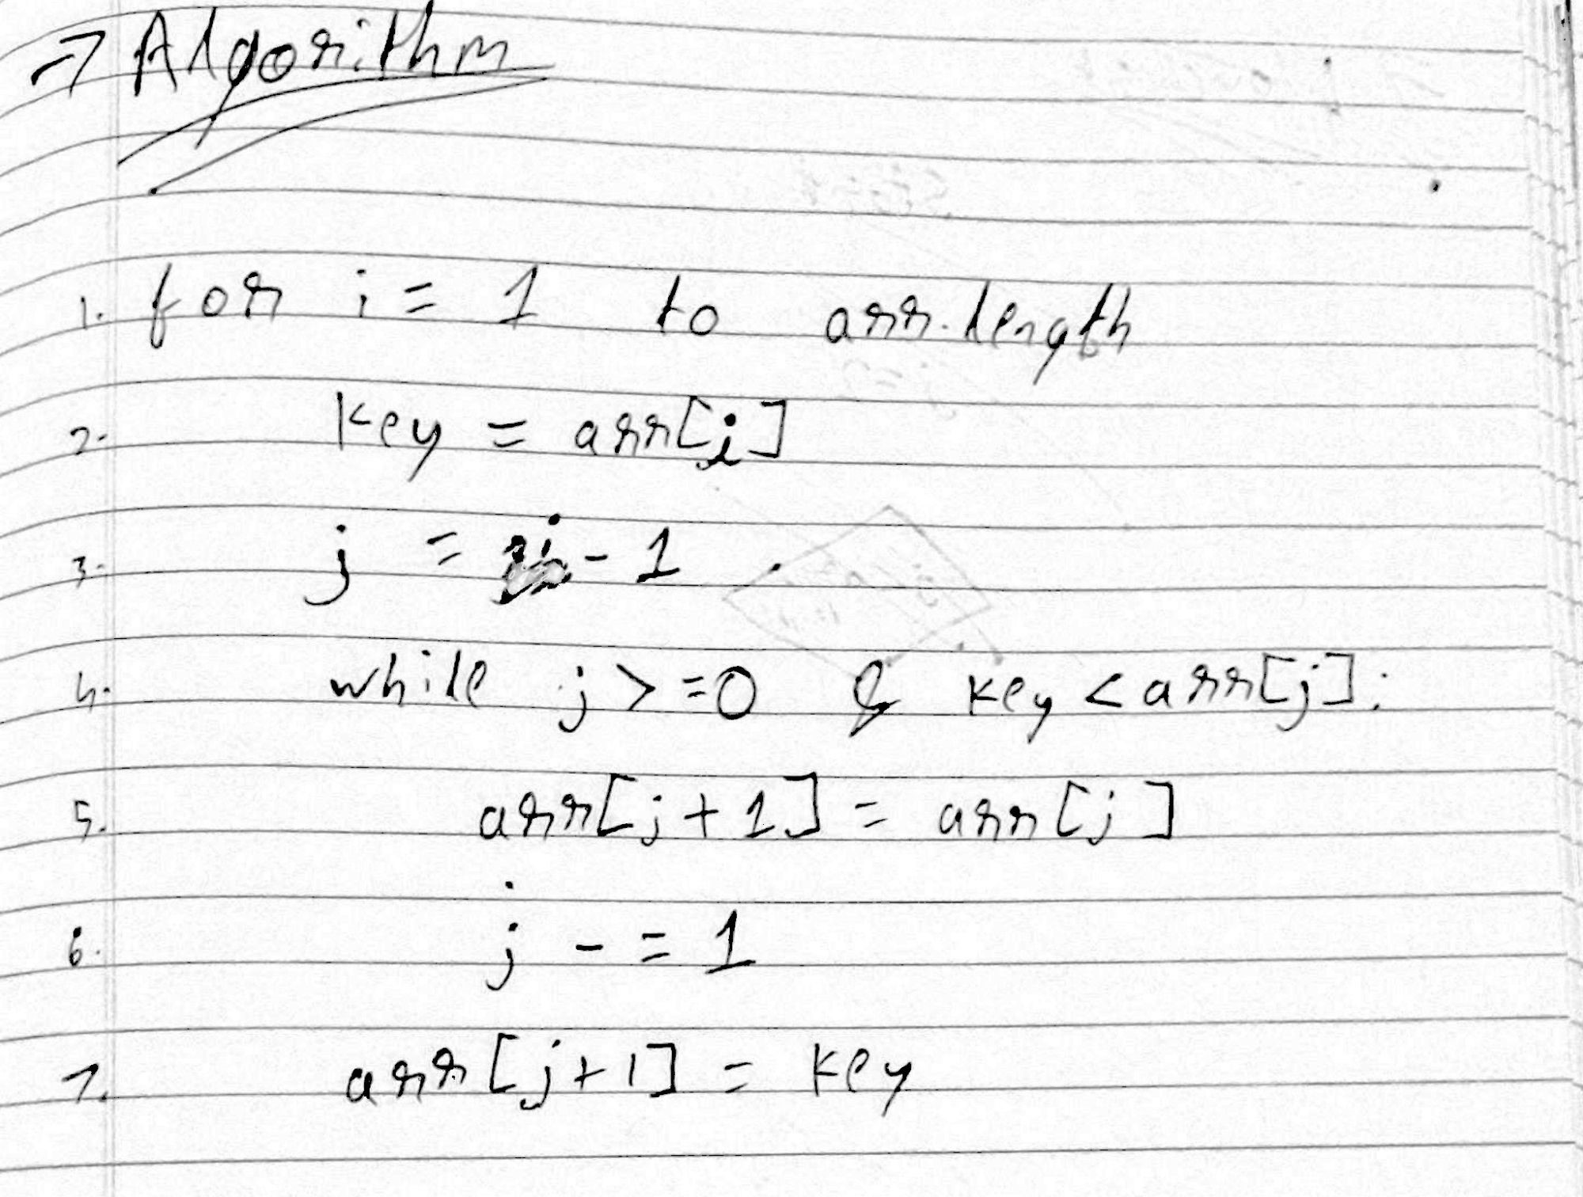

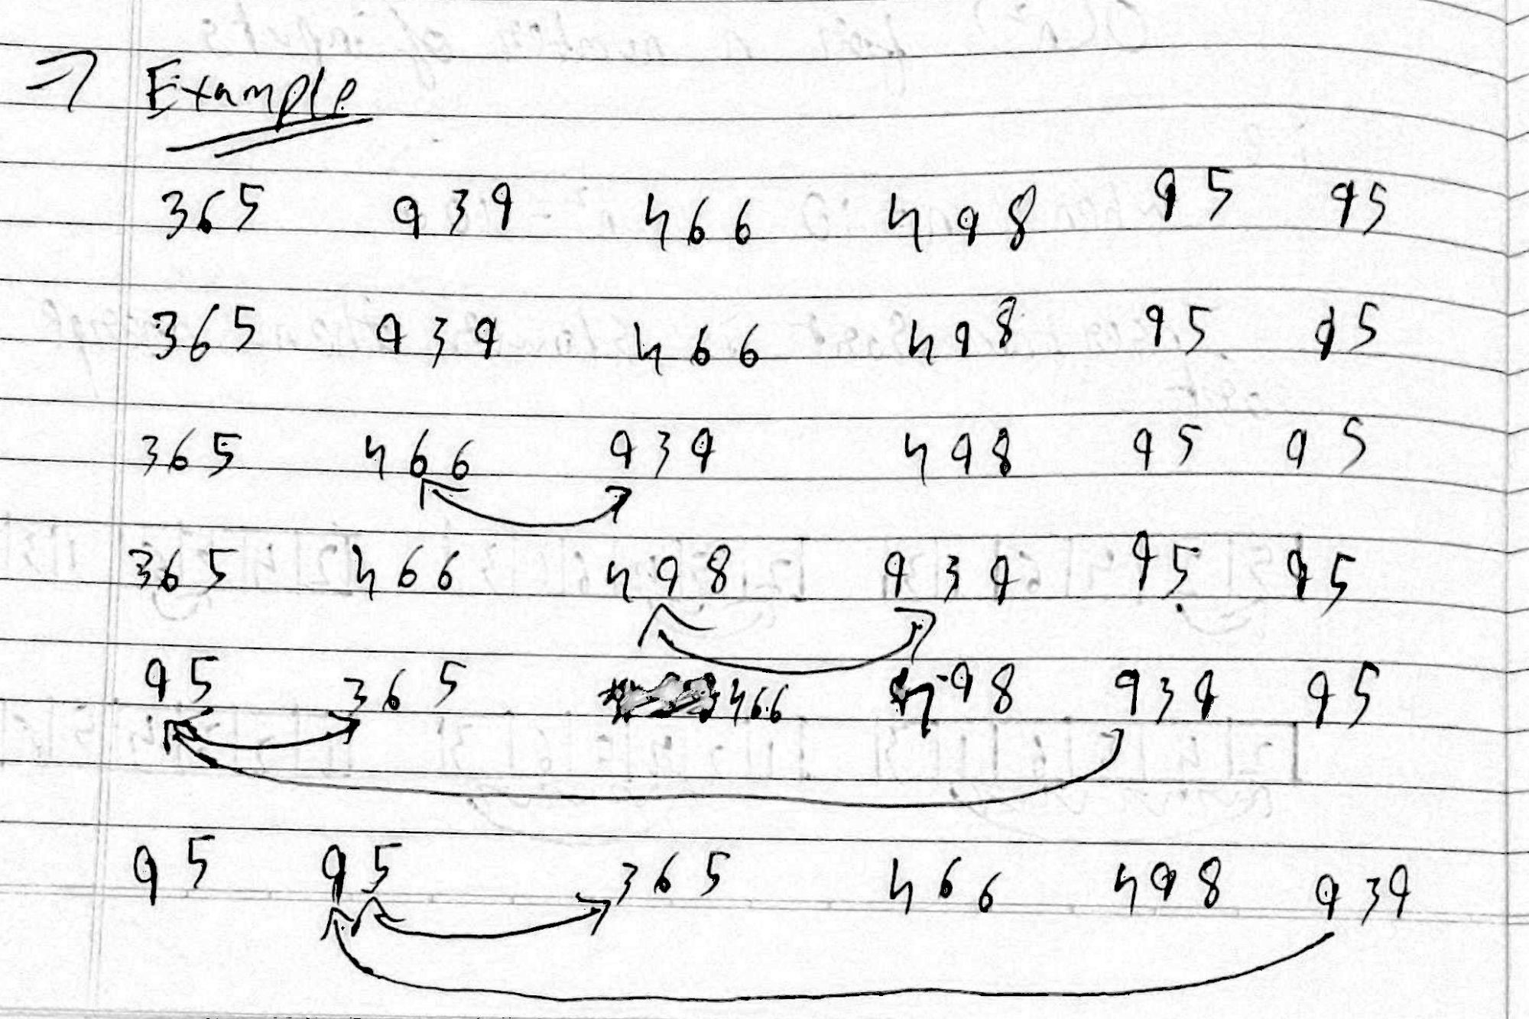

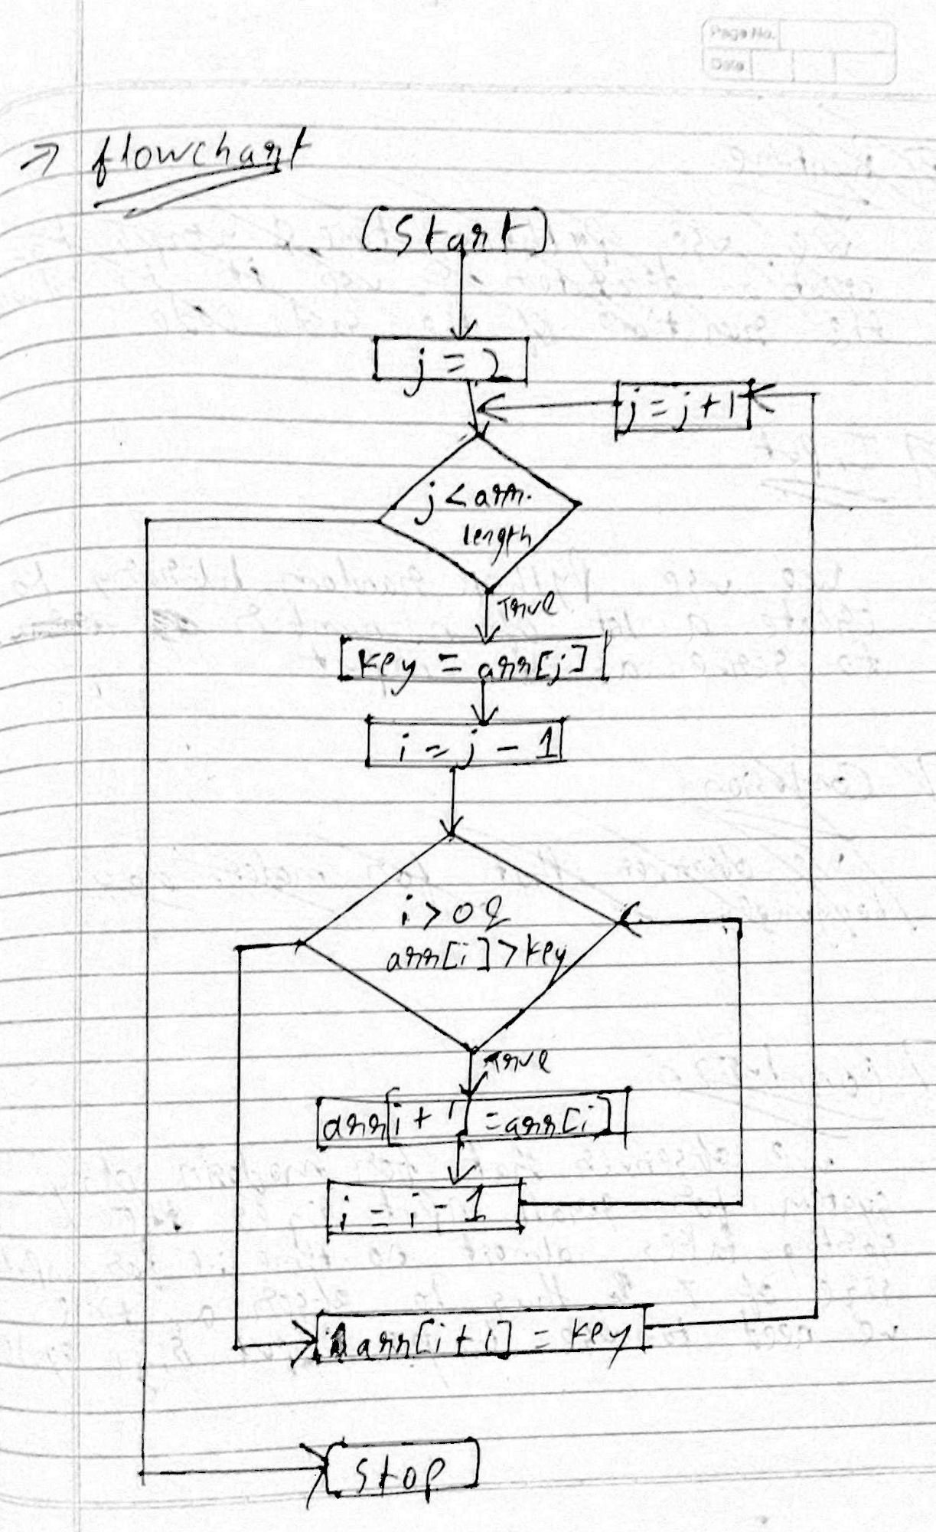

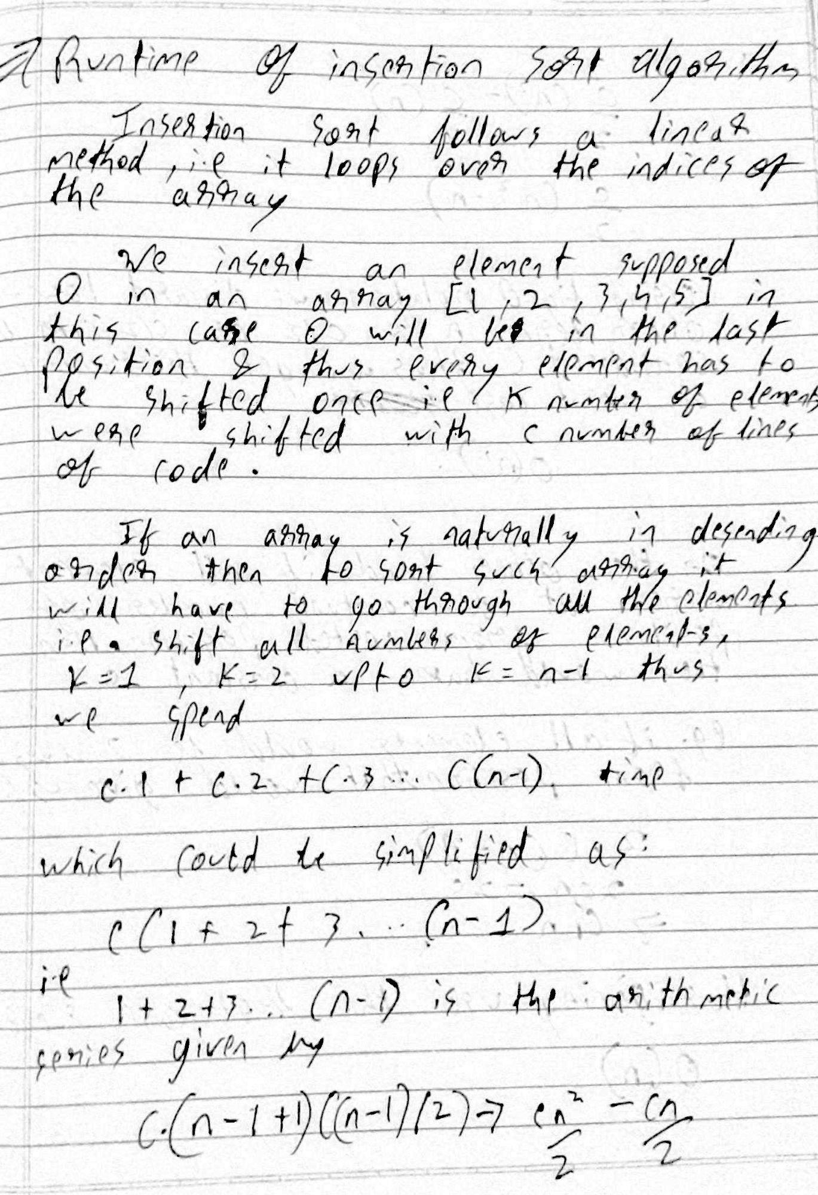

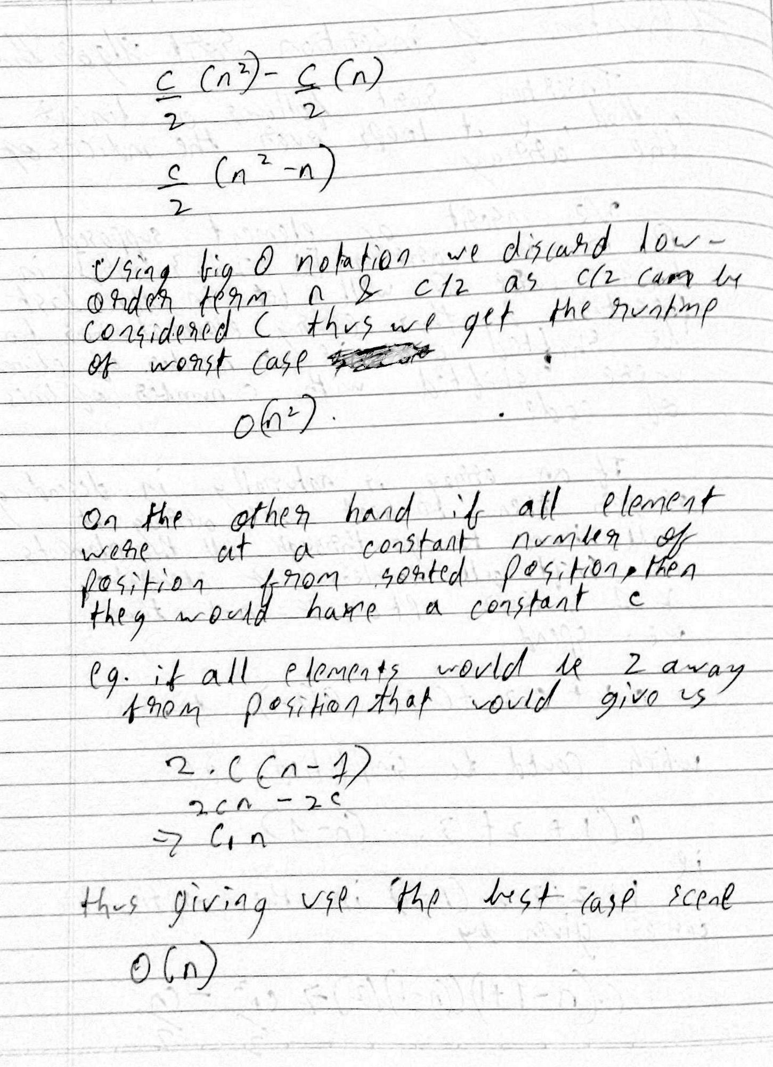

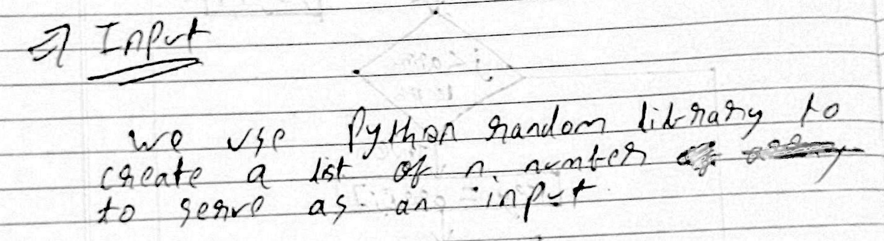

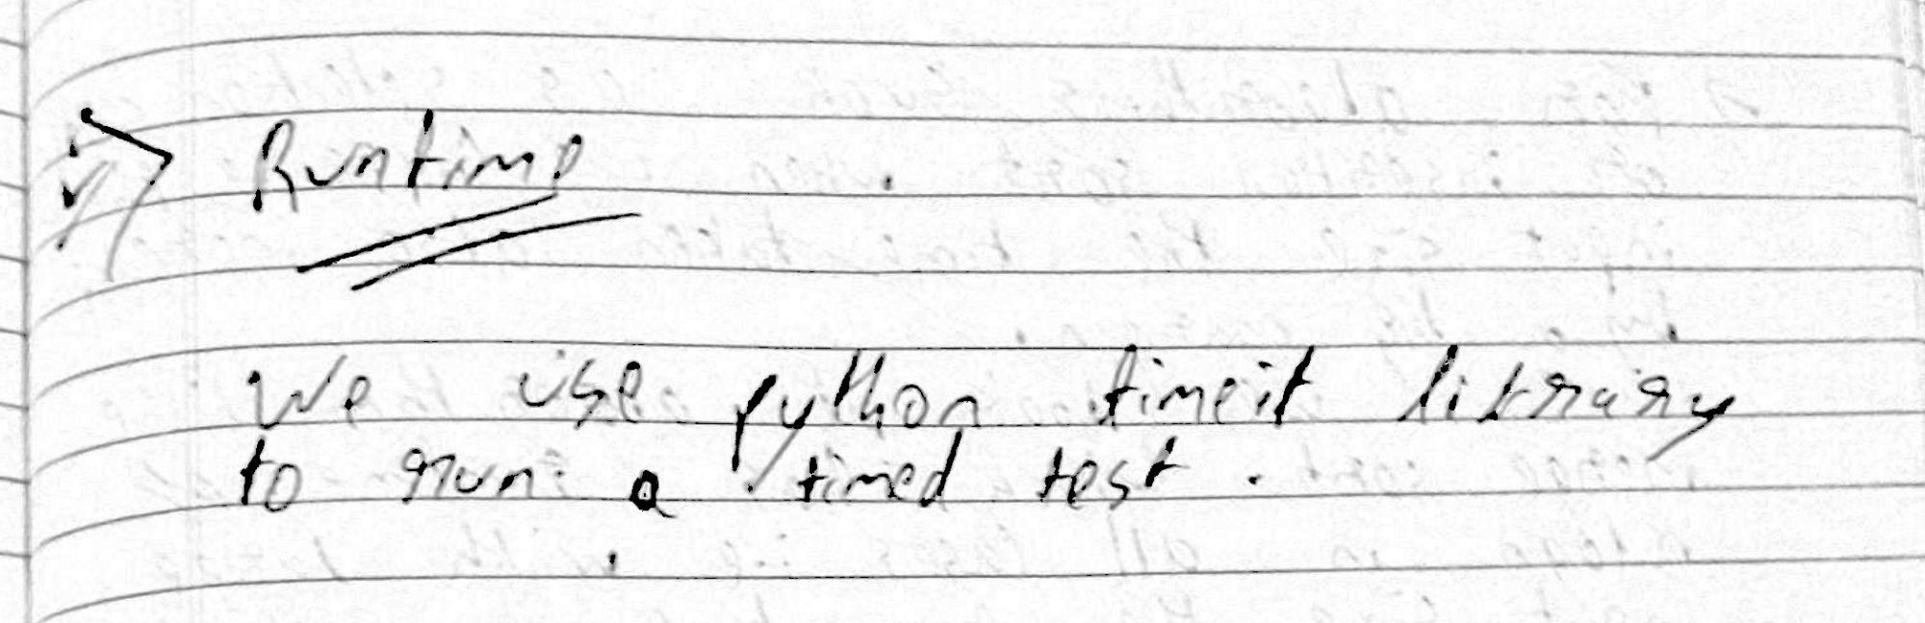

Program

1. from functools import wraps
2. import timeit
3. import random
5. def insertion_sort(arr):
6. # Traverse through 1 to len(arr)
7. for i in range(1, len(arr)):
8. key = arr[i]
9. j = i-1
10. while j >=0 and key < arr[j] :
11. arr[j+1] = arr[j]
12. j -= 1
13. arr[j+1] = key
14. return arr

17. if __name__ == "__main__":
18. arr=[]
19. for i in range (1,10):
20. n = random.randint(0,1000)
21. arr.append(n)
22. print(insertion_sort(arr))

For input size of 10

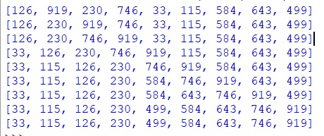

Timing code

1. SETUP_CODE = '''
2. from __main__ import insertion_sort
3. import random
4. '''
6. TEST_CODE = '''
7. arr=[]
8. for i in range (1,5):
9. n = random.randint(0,1000)
10. arr.append(n)
11. insertion_sort(arr)'''
13. times = timeit.timeit(setup = SETUP_CODE,
14. stmt = TEST_CODE,
15. number = 100)
17. print(times)

Output time with array of size 10



Output with array of size 100000



